FITNESS CHATBOT

Submitted in partial fulfilment of the
Requirements for the award of the degree

Of

Bachelor of Technology

In

Artificial Intelligence & Machine Learning

By:

Guneesh Dua(20213211622)



Guru Tegh Bahadur Institute of Technology
Guru Gobind Singh Indraprastha University
Dwarka, New Delhi
Year 2022-2026

Declaration

I affirm that the content presented in the dissertation titled "Fitness Chatbot", submitted in partial fulfilment of the requirements for the degree of Bachelor of Technology in Artificial Intelligence & Machine Learning at Guru Tegh Bahadur Institute of Technology, affiliated with Guru Gobind Singh Indraprastha University, New Delhi, is a genuine representation of my work conducted under the supervision of seminar for machine learning training program.

Date:- Guneesh Dua (20213211622)

CHAPTER1:- ABSTRACT
The "Fitness Chatbot" project aims to develop an intelligent, AI-powered virtual assistant dedicated to helping users achieve their fitness and wellness goals. As interest in personal health and fitness continues to grow, there is an increasing demand for accessible, cost-effective, and personalized fitness solutions. This fitness chatbot addresses this need by acting as a digital personal trainer that is available 24/7, providing users with personalized workout recommendations, dietary advice, and motivation. By leveraging natural language processing (NLP) and machine learning, the chatbot can understand and respond to a wide range of user queries related to fitness and wellness.

The core functionalities of the fitness chatbot include creating tailored workout plans, offering meal suggestions based on dietary preferences, tracking progress over time, and providing answers to general fitness-related questions. Designed for simplicity and user engagement, the chatbot aims to help users stay on track with their fitness goals, regardless of their fitness level, lifestyle, or schedule. It offers a conversational interface, allowing users to interact with it as they would with a personal trainer, making the fitness journey more interactive and supportive.

The chatbot is built using a combination of backend technologies such as Python for AI integration, database management systems for storing user data, and various NLP libraries for understanding user inputs and generating responses. During development, the project goes through multiple phases, including requirement gathering, design, development, testing, and deployment, ensuring a structured and reliable end product. To validate its effectiveness, the chatbot is tested rigorously on key performance indicators like response accuracy, user engagement, and reliability.

In conclusion, this report presents the fitness chatbot as a practical solution to common barriers in personal fitness, such as lack of time, limited knowledge, and motivation challenges. The chatbot has the potential to revolutionize how users approach fitness, providing personalized, on-demand support and enabling them to achieve sustainable health improvements. Future development could expand its functionalities further, incorporating advanced analytics, integration with wearable devices, and multilingual support, making it an even more comprehensive fitness companion for users world.
CHAPTER2:-INTRODUCTION

In today’s world, health and fitness have become priorities for people of all ages. With the rise in sedentary lifestyles and the increase in health-related issues, maintaining physical well-being is more important than ever. However, many individuals face challenges in achieving their fitness goals due to lack of time, knowledge, motivation, or access to professional trainers. Technology has the potential to bridge this gap, offering accessible, cost-effective, and personalized fitness solutions. Among various technological innovations, chatbots have emerged as powerful tools to assist individuals in their health and fitness journeys.

The Rise of Digital Health and Fitness Solutions

Digital fitness solutions, such as mobile apps, wearables, and online trainers, have transformed how people approach physical wellness. Many fitness applications provide users with workout plans, track their progress, and offer dietary guidance. However, these applications often lack a conversational interface that allows for personalized, real-time interaction. A fitness chatbot can fill this gap, acting as a virtual personal trainer available 24/7 to provide guidance, answer questions, and offer encouragement. With the rapid advancements in artificial intelligence (AI) and natural language processing (NLP), chatbots can now understand and respond to a wide range of user inputs, making them more interactive and engaging than ever before.

What is a Fitness Chatbot?

A fitness chatbot is an AI-powered virtual assistant that interacts with users in natural language, helping them with their fitness goals. Through a conversational interface, users can ask the chatbot questions about workouts, nutrition, or health in general, and the chatbot provides tailored responses based on the user’s preferences, goals, and fitness level. Unlike generic fitness apps, a fitness chatbot can engage in a dialogue with the user, making the experience more interactive, personalized, and supportive.

The chatbot’s primary functions include recommending workout routines, offering dietary advice, tracking user progress, and providing motivation. By utilizing NLP, the chatbot can interpret user queries, analyze their fitness history, and respond with personalized guidance. For example, if a user asks for a workout plan to build strength, the chatbot can generate a routine based on that user’s experience level and goals. If a user needs dietary advice, the chatbot can recommend meals aligned with their preferences and caloric needs.

Importance of Fitness Chatbots in the Modern World

Fitness chatbots offer several advantages over traditional fitness solutions. First, they provide 24/7 availability, allowing users to access fitness advice at any time, whether at home, at the gym, or on the go. This constant availability makes it easier for users to integrate fitness into their daily lives, removing the constraints of location and time.

Second, fitness chatbots provide personalized guidance that adapts to each user’s unique needs. By using AI algorithms to analyze user data, the chatbot can tailor workout and dietary recommendations specifically for each individual. This level of personalization helps users achieve their fitness goals more effectively, as they receive advice suited to their body type, lifestyle, and fitness objectives.

Finally, fitness chatbots offer motivation and accountability, which are crucial for long-term success in fitness. The chatbot can send reminders, track progress, and celebrate milestones, helping users stay engaged and committed to their fitness journey. By interacting with users on a regular basis, the chatbot can provide the encouragement needed to overcome motivation challenges.

CHAPTER3:-Aim & Objective

This section clearly defines the purpose and goals of the project. It includes:

Aim: To create a user-friendly fitness chatbot that helps users achieve and maintain fitness goals.

Objectives:

Deliver personalized workout recommendations based on user preferences and fitness levels.

Offer dietary advice and meal suggestions.

Track user activity and provide feedback on their progress.

Answer general fitness questions and provide motivational support.

Potentially integrate with wearable devices or fitness trackers to enhance functionality.

CHAPTER4:- Requirement Analysis

The Requirement Analysis section outlines the specific needs and technical requirements for the development of the fitness chatbot. This phase is crucial for understanding the functionality, performance, and technical constraints that will shape the project. The requirements are divided into two categories: functional and non-functional requirements. Additionally, this section describes the technology stack that will be used to build and implement the chatbot.

1. Functional Requirements

Functional requirements specify the core functionalities and capabilities that the fitness chatbot must possess to meet user expectations. These requirements define what the chatbot should be able to do:

Natural Language Processing (NLP) Capability:

The chatbot should be able to understand and process user queries in natural language. This includes recognizing different intents, such as asking for workout suggestions, dietary advice, or fitness tips.

The NLP engine should support basic fitness-related vocabulary and context, enabling the chatbot to answer questions accurately and hold meaningful conversations.

Workout Recommendations:

The chatbot should generate customized workout plans for users based on their fitness level, goals (e.g., strength, weight loss, endurance), preferences, and any available equipment.

Users should be able to specify the type of exercise they prefer or the body parts they want to focus on, and the chatbot should provide suitable exercises.

Dietary Advice and Meal Suggestions:

The chatbot should be capable of providing dietary recommendations and meal suggestions aligned with users' goals, dietary restrictions, and preferences (e.g., vegan, low-carb, high-protein).

The chatbot should calculate and suggest appropriate calorie intake and macronutrient distribution to help users achieve their health goals.

Progress Tracking:

The chatbot should track the user's progress over time, including workout completion, improvements in strength or endurance, and weight changes.

Progress tracking may include visual representations, such as charts or summaries, to motivate users and help them understand their improvements.

Goal Setting and Reminders:

The chatbot should allow users to set fitness goals (e.g., losing weight, gaining muscle) and provide reminders or motivational messages to help them stay on track.

It should periodically check in with users, offering encouragement, reminders to exercise, or suggestions to review their diet.

General Fitness and Health Information:

The chatbot should be able to answer common fitness-related questions, such as “What is a good exercise for abs?” or “How much protein should I consume daily?”

The chatbot should serve as a knowledge base, providing users with reliable information on exercise techniques, nutritional facts, and general wellness tips.

2. Non-Functional Requirements

Non-functional requirements specify the quality attributes, performance standards, and usability guidelines that the fitness chatbot must meet. These requirements ensure that the chatbot is reliable, secure, and user-friendly:

Usability:

The chatbot should have an intuitive and user-friendly interface that enables users to navigate its features easily. The conversation flow should be smooth, with clear options and prompts to guide users through various tasks.

Performance:

The chatbot should respond to user queries quickly, with a response time ideally under 2 seconds for most interactions. Quick response times are essential for maintaining user engagement.

It should be scalable to handle a large number of users simultaneously without performance degradation.

Data Security and Privacy:

The chatbot must ensure secure handling of user data, including personal information, fitness goals, and health-related data.

Compliance with privacy standards, such as GDPR (General Data Protection Regulation), should be considered, especially if the chatbot handles sensitive data.

User data should be stored securely with encryption to prevent unauthorized access or breaches.

Reliability and Availability:

The chatbot should have high availability, ideally with minimal downtime to allow users to access fitness assistance anytime they need it.

Mechanisms for error handling and recovery should be in place to handle unexpected issues smoothly and maintain user satisfaction.

Adaptability:

The chatbot should be flexible enough to integrate with other platforms or applications (e.g., social media, fitness apps, wearable devices) to expand its functionality.

It should be designed to support future upgrades, such as adding new languages or expanding its fitness knowledge base.

3. Technology Stack

The technology stack specifies the tools, programming languages, and frameworks that will be used to develop and deploy the chatbot:

Backend Technologies:

Programming Language: Python or Node.js, both of which are well-suited for AI applications and have rich libraries for building chatbots.

Frameworks: Flask or Django (Python) or Express (Node.js) for developing the chatbot's backend, handling API requests, and managing user interactions.

Natural Language Processing (NLP):

Libraries/Frameworks: spaCy, NLTK, or Hugging Face Transformers for NLP tasks, including intent recognition, text analysis, and response generation.

Machine Learning Models: Pre-trained models such as BERT or GPT for advanced understanding of user queries. These models can be fine-tuned for fitness-related terminology and phrases to improve response accuracy.

Database:

Database Management System (DBMS): MongoDB or MySQL to store user data, such as profiles, activity history, and preferences.

Data Storage: The database will store user information securely and efficiently, enabling quick retrieval and updates as users interact with the chatbot.

Frontend (User Interface):

If the chatbot is deployed as a web or mobile app, a frontend framework such as React (for web) or Flutter (for mobile) can be used to design the interface.

Alternatively, the chatbot could be deployed on messaging platforms (e.g., Facebook Messenger, WhatsApp), which would eliminate the need for a standalone frontend.

Integration Tools:

APIs and webhooks may be used to integrate the chatbot with third-party applications or devices, such as fitness tracking apps or wearable devices.

Platform Integration: The chatbot could be integrated with platforms like Slack, Telegram, or Facebook Messenger, allowing users to access it conveniently from their preferred communication platform.

This detailed Requirement Analysis section ensures that all necessary functionalities, quality standards, and technical tools are considered in the development of the fitness chatbot. By defining these requirements, the project team can proceed with a clear understanding of what the chatbot needs to accomplish and how it should perform, setting the foundation for a successful implementation.

CHAPTER5:- System Phases

The development of the fitness chatbot follows a structured approach, divided into several phases. Each phase is essential to ensure that the chatbot is reliable, user-friendly, and capable of meeting the functional requirements specified in the Requirement Analysis. This section provides a detailed description of each system phase, from planning and design to development, testing, and deployment.

1. Planning and Requirement Gathering

In this initial phase, the project team defines the overall goals and objectives of the fitness chatbot. This phase involves identifying the target users, understanding their fitness needs, and defining how the chatbot will help them achieve their goals. The project team also gathers the necessary requirements for the system, both functional and non-functional, as outlined in the Requirement Analysis section. Key activities in this phase include:

Conducting research on similar products to identify unique features and areas for improvement.

Gathering input from fitness experts, personal trainers, and potential users to understand their needs.

Defining the chatbot’s key functionalities, such as workout recommendations, dietary advice, and progress tracking.

Outlining the technical requirements, such as the technology stack, data storage, and security needs.

2. System Design

The System Design phase involves creating the architecture and user interaction flow of the fitness chatbot. The goal is to design a system that is both functional and user-friendly. During this phase, the team defines the overall structure of the chatbot, including its backend, frontend, and integration with NLP models. This phase typically involves the following steps:

Architecture Design: Developing a high-level architecture that outlines how different components (e.g., NLP engine, database, user interface) interact with each other.

Database Design: Designing a database schema to store user profiles, fitness goals, workout history, and other relevant data. The database should be optimized for quick retrieval and secure storage of sensitive information.

User Interface (UI) Design: Creating wireframes or prototypes of the chatbot's interface to ensure a smooth and intuitive user experience. This includes designing the conversation flow, options for interaction, and visual elements.

Integration Planning: Outlining the methods and APIs needed to integrate the chatbot with other platforms or applications (e.g., messaging apps, fitness trackers).

3. Development

The Development phase involves coding and building each component of the fitness chatbot based on the design specifications. This phase is where the system begins to take shape. The development is often split into backend and frontend development:

Backend Development:

Building the core functionalities, including the NLP engine for understanding user queries and generating responses.

Implementing the recommendation engine for workouts and meal plans, based on user data and preferences.

Developing the progress-tracking functionality, which stores user achievements and updates over time.

Frontend Development:

Designing a user-friendly interface that allows users to interact with the chatbot seamlessly. This could include building a web or mobile app if the chatbot is standalone, or integrating it into popular messaging platforms.

Creating options for users to input their goals, track progress, and view workout or diet recommendations.

Integration of Machine Learning Models:

Fine-tuning NLP models (e.g., BERT, GPT) to improve the chatbot’s understanding of fitness-related language and user intents.

Integrating these models with the backend to ensure smooth and accurate responses to user queries.

4. Testing

The Testing phase ensures that the fitness chatbot functions as expected and meets quality standards. Testing is crucial to identifying and fixing any issues or bugs before deployment. This phase includes several types of testing:

Unit Testing: Testing individual components of the chatbot (e.g., NLP functions, recommendation algorithms) to ensure they work correctly in isolation.

Integration Testing: Ensuring that different components (e.g., NLP engine, database, UI) work together seamlessly and data flows correctly between them.

Functional Testing: Verifying that the chatbot’s core functionalities, such as workout recommendations, dietary advice, and progress tracking, work as expected.

User Interface Testing: Testing the chatbot’s interface to ensure that it is intuitive and user-friendly. This includes checking for smooth navigation, responsive design, and ease of use.

Performance Testing: Evaluating the chatbot’s response times and performance under load to ensure it can handle multiple user interactions simultaneously without lag.

Security Testing: Ensuring the chatbot meets data security and privacy requirements by testing for vulnerabilities in data storage, user authentication, and data handling processes.

During this phase, feedback is gathered from beta users to identify any additional improvements or potential issues. The chatbot may undergo several iterations of testing and refinement to achieve optimal performance.

5. Deployment

Once testing is complete and the chatbot has been fine-tuned, it is ready for deployment. The Deployment phase involves launching the fitness chatbot so users can begin interacting with it. Key activities in this phase include:

Server Setup: Configuring the servers and deploying the backend components to a cloud platform (e.g., AWS, Azure) to ensure high availability and scalability.

Database Setup: Setting up the database in a secure and reliable environment, ensuring that user data is stored safely and can be accessed quickly.

Release to Target Platforms: Deploying the chatbot on the chosen platforms, such as a standalone mobile app, web application, or popular messaging platforms like Facebook Messenger or WhatsApp.

Monitoring Setup: Implementing monitoring tools to track the chatbot’s performance, user interactions, and error rates. This ensures that the team can quickly identify and resolve any issues that arise post-launch.

6. Maintenance and Updates

The Maintenance and Updates phase involves monitoring the chatbot’s performance, addressing any issues that arise, and releasing updates to improve functionality. Continuous improvement is essential to keep the chatbot relevant and useful to users. Key activities in this phase include:

Bug Fixes and Issue Resolution: Addressing any bugs or issues reported by users to ensure a seamless experience.

Performance Optimization: Monitoring the chatbot’s performance metrics and making adjustments to improve response times, reliability, and scalability.

Feature Enhancements: Adding new features or refining existing ones based on user feedback and emerging fitness trends. For example, new workout types, diet options, or integration with additional fitness tracking devices could be added over time.

Model Retraining and Fine-Tuning: Periodically retraining the NLP and recommendation models with new data to improve accuracy and adapt to changing user preferences or language usage.

Security and Compliance Updates: Keeping the chatbot’s security features up-to-date to ensure data privacy and compliance with relevant regulations, such as GDPR.

CHAPTER6:- System Design & Methodology

The System Design phase provides a blueprint for the architecture, components, data flow, and user interaction of the fitness chatbot. This phase translates the functional requirements into a structured design that serves as a guide for the development team. The design ensures that each component interacts effectively and contributes to the overall functionality of the chatbot. The system design of the fitness chatbot can be divided into several key areas: architecture, database design, user interface, and integration with NLP and machine learning models.

1. System Architecture

The system architecture defines the high-level structure of the fitness chatbot and outlines how various components interact with each other. A typical architecture for a chatbot includes the following components:

Frontend: The user interface through which users interact with the chatbot. This could be a standalone mobile app, web app, or an integration with popular messaging platforms like Facebook Messenger, WhatsApp, or Slack. The frontend is responsible for displaying messages, collecting user input, and sending user requests to the backend.

Backend: The backend is the core of the chatbot's logic. It processes user inputs, manages user data, handles requests, and generates responses. The backend consists of:

NLP Engine: Responsible for understanding user queries by identifying intents and extracting entities. The NLP engine uses models like BERT, spaCy, or custom-trained models to interpret natural language input.

Recommendation Engine: This component generates personalized workout plans, dietary advice, and other fitness recommendations based on user data.

Progress Tracker: Tracks and stores user activities, achievements, and progress toward fitness goals. This data helps the chatbot provide tailored responses and insights over time.

API Integrations: Allows the chatbot to connect with third-party fitness apps, wearable devices, or platforms for enhanced functionalities.

Database: Stores user data, including profiles, preferences, workout history, and dietary information. The database is designed for secure and efficient storage, allowing quick access to data when needed.

Machine Learning Models: ML models are used for NLP and recommendations. For example, an NLP model helps interpret user input, while a recommendation model suggests suitable workouts or dietary plans. These models may be hosted on cloud platforms like AWS or Google Cloud for scalability.

External APIs: These may include APIs for fitness data (e.g., exercise databases), nutrition information, or third-party integration (e.g., with wearables like Fitbit).

2. Database Design

The database design ensures efficient data storage and retrieval, enabling the chatbot to manage user information, track progress, and provide personalized recommendations. The database should be structured to support various types of data while maintaining data security and privacy. Key components of the database include:

User Profile:

Contains user-specific information such as name, age, gender, fitness goals, preferences, and health details (e.g., weight, height).

Stores user goals (e.g., weight loss, muscle gain) to personalize recommendations.

Workout History:

Logs each workout session, including date, time, type of exercise, duration, intensity, and completion status.

This data is used to track progress and provide insights or recommendations based on previous workouts.

Dietary Preferences and Meal Log:

Stores user dietary preferences (e.g., vegetarian, keto) and any food restrictions.

Tracks daily meals and calories, helping the chatbot make dietary recommendations that align with user goals.

Progress Tracker:

Maintains records of user achievements, including metrics such as weight changes, strength improvements, and endurance growth.

Used to generate visual progress updates, motivating users and enabling the chatbot to provide more tailored suggestions.

The database may be implemented using a relational database like MySQL or a NoSQL database like MongoDB, depending on the complexity and scalability requirements. Security and encryption protocols should be implemented to protect sensitive user information.

3. User Interface (UI) Design

The User Interface (UI) design is essential for creating an intuitive and user-friendly experience. A well-designed UI enables users to interact with the chatbot smoothly and efficiently. Key aspects of the UI design include:

Conversational Flow:

The chatbot’s responses should follow a logical and friendly conversational flow. It should guide users by providing options, asking relevant questions, and clarifying information when needed.

Users should be able to select their goals, preferences, and other options through quick replies, buttons, or text input.

Dashboard:

A personalized dashboard can display a summary of user activities, workout history, dietary progress, and goal tracking.

The dashboard may include visual elements like charts or graphs that show progress over time, helping users stay motivated.

Input and Output Options:

Users should be able to input data in a variety of ways, such as typing, selecting from options, or uploading media (e.g., images of food).

Output options may include text responses, images (e.g., exercise illustrations), and multimedia (e.g., instructional videos for workouts).

Notifications and Reminders:

The chatbot should send reminders for workouts, diet plans, or goals. These notifications can be personalized and timed based on user preferences.

Motivational messages and progress updates should also be integrated to encourage users to stay on track.

The UI can be designed as a standalone web/mobile application or integrated with existing messaging platforms. In a standalone app, frameworks like React (for web) or Flutter (for mobile) can be used to build the interface.

4. Natural Language Processing (NLP) Integration

Natural Language Processing is a key component of the fitness chatbot, allowing it to understand user inputs and generate appropriate responses. The NLP component includes:

Intent Recognition:

Determines the user’s intent (e.g., asking for a workout plan, seeking dietary advice, tracking progress). Intent recognition is achieved using models like spaCy or BERT, which can be trained to identify fitness-related intents accurately.

Entity Extraction:

Identifies specific entities in the user’s input, such as dates (e.g., “next Monday”), numbers (e.g., “run 5 kilometers”), and fitness-specific terms (e.g., “cardio,” “protein”). Entity extraction is essential for customizing responses based on user input.

Response Generation:

Once the intent and entities are recognized, the chatbot generates a response tailored to the user’s needs. This could involve retrieving information from the database, creating a workout or meal plan, or providing general fitness advice.

Predefined response templates, dynamic text generation, or even generative language models (like GPT) can be used to ensure that responses are coherent and contextually relevant.

Sentiment Analysis (Optional):

By analyzing the sentiment of user messages (e.g., frustration, excitement), the chatbot can tailor its tone and responses. For instance, if a user expresses discouragement, the chatbot could offer motivational messages.

5. Recommendation Engine

The recommendation engine is responsible for generating personalized workout and diet plans for the user. It uses data from the user profile and fitness goals to provide tailored suggestions:

Workout Recommendations:

The engine suggests exercises based on the user’s goals, experience level, available equipment, and fitness preferences. For example, if the user wants to build strength and has access to weights, the engine will suggest weightlifting exercises.

It also takes into account the user’s progress and previous workouts to avoid repetitive exercises and maintain variety.

Dietary Recommendations:

Based on the user’s dietary preferences, restrictions, and goals, the engine recommends meal plans and suggests calorie intake and macronutrient distribution (e.g., protein, carbs, fats).

The engine may use APIs to fetch meal plans from external sources or generate simple diet plans based on commonly available foods.

Progress Tracking and Adjustment:

As users progress toward their fitness goals, the recommendation engine adapts its suggestions to keep them challenged and aligned with their goals. For example, if a user’s endurance has improved, the chatbot may recommend longer or more intense cardio sessions.

6. Security and Privacy

Given the sensitive nature of fitness and health data, the system design must include robust security measures to protect user information. Key considerations include:

Data Encryption:

All sensitive data, including user profiles, workout history, and dietary information, should be encrypted in transit and at rest.

Secure communication protocols (e.g., HTTPS) should be used to protect data from interception during transmission.

Access Control:

The system should enforce access control measures to ensure that only authorized users have access to their data. User authentication (e.g., passwords, biometrics) should be implemented to prevent unauthorized access.

Compliance with Privacy Standards:

The design should ensure compliance with relevant privacy regulations, such as GDPR. Users should have control over their data and be able to delete or modify it as needed.

This System Design section ensures that all components of the fitness chatbot are well-planned and interconnected, enabling a smooth, secure, and personalized user experience. From defining the architecture and database to designing the user interface, NLP integration, and recommendation engine, each aspect contributes to building a comprehensive fitness assistant that can effectively support users in achieving their health and wellness goals.

CHAPTER7:- Testing & Validation

The Testing and Validation phase is a crucial step in the development of the fitness chatbot, ensuring that it functions as expected, meets quality standards, and provides a seamless user experience. This phase involves systematically checking each component of the system, identifying and fixing issues, and validating that the chatbot’s responses and recommendations are accurate, reliable, and user-friendly. The following types of testing are typically conducted to ensure the chatbot's effectiveness and robustness.

1. Unit Testing

Unit testing involves testing individual components of the chatbot’s code to ensure they function as intended in isolation. Each module, such as the NLP engine, recommendation engine, or progress tracker, is tested separately to confirm that it handles input and produces the correct output. Key aspects include:

NLP Intent Recognition: Testing that the NLP component correctly identifies user intents (e.g., workout recommendations, dietary advice).

Entity Extraction: Ensuring that the chatbot accurately extracts relevant entities, such as dates, exercise names, dietary restrictions, and numeric values.

Response Generation: Verifying that response templates and dynamic response generation work correctly for each type of user query.

Unit testing allows for early identification of issues within specific components, making it easier to isolate and resolve problems before they impact other parts of the system.

2. Integration Testing

Integration testing ensures that all components of the chatbot work seamlessly together. During this phase, individual modules are combined and tested as a complete system to validate data flow, component interaction, and end-to-end functionality. Key areas include:

NLP and Database Integration: Testing that the chatbot can retrieve and store user data (e.g., workout history, meal preferences) from the database based on user input.

Recommendation Engine Integration: Ensuring that the recommendation engine produces relevant workout or dietary suggestions based on user data, and that these suggestions are correctly delivered through the chatbot’s UI.

User Interface and Backend Communication: Verifying that the frontend accurately captures user input, sends it to the backend, and displays the correct response.

This phase ensures that the chatbot operates smoothly and that all parts work harmoniously to provide a cohesive user experience.

3. Functional Testing

Functional testing verifies that the fitness chatbot performs its intended functions correctly. Each feature is tested to ensure that it meets the specified requirements and performs as expected. Key functional tests include:

Workout Recommendation: Testing that the chatbot provides personalized workout plans based on user goals, experience level, and available equipment.

Dietary Advice: Verifying that the chatbot suggests suitable meal plans based on user preferences, dietary restrictions, and caloric needs.

Progress Tracking: Ensuring that the chatbot accurately records and updates user progress, displaying metrics like workout completion, calories burned, and changes in weight or fitness levels.

User Authentication: Testing the login and registration process to confirm that users can securely create accounts, log in, and access their personalized data.

Functional testing ensures that each feature works correctly and that the chatbot provides users with accurate and relevant information.

4. User Interface Testing

User interface (UI) testing focuses on the usability and visual aspects of the chatbot. This type of testing ensures that the chatbot is easy to navigate, visually appealing, and provides a positive user experience. Key areas of UI testing include:

Responsive Design: Ensuring that the chatbot’s interface adapts to different devices and screen sizes, such as mobile phones, tablets, and desktops.

Navigation Flow: Testing that users can easily navigate through different options, view workout and dietary recommendations, and access their progress without confusion.

Input Validation: Verifying that input fields (e.g., user preferences, fitness goals) accept valid data and provide feedback when incorrect data is entered.

Visual Consistency: Checking that colors, fonts, buttons, and icons are consistent and visually appealing across the entire application.

UI testing ensures that the chatbot is user-friendly, intuitive, and visually coherent, enhancing the overall user experience.

5. Performance Testing

Performance testing evaluates the chatbot’s response time, speed, and ability to handle multiple users simultaneously. This type of testing is essential for ensuring a smooth and responsive experience, especially when the chatbot is deployed to a large user base. Key areas include:

Response Time: Testing how quickly the chatbot responds to user queries and delivers information, including workout and dietary recommendations.

Load Testing: Evaluating the chatbot’s performance under varying levels of user traffic to ensure that it can handle high demand without crashing or slowing down.

Scalability Testing: Testing the chatbot’s ability to scale up and handle an increased number of users or requests as it grows in popularity.

Performance testing helps identify potential bottlenecks and ensures that the chatbot remains responsive and reliable, even under heavy usage.

6. Security Testing

Security testing is essential for protecting user data, ensuring privacy, and preventing unauthorized access to the chatbot. This phase evaluates the system’s security measures and verifies that sensitive information is protected. Key security tests include:

Data Encryption: Ensuring that all user data, including personal information, fitness history, and dietary preferences, is encrypted in transit and at rest.

User Authentication: Testing the login system to confirm that only registered users can access their accounts and personal data.

Data Access Control: Verifying that users can only access their own data and cannot view or modify others’ data.

Vulnerability Scanning: Conducting scans to identify potential vulnerabilities, such as SQL injection, cross-site scripting (XSS), and other common security threats.

Security testing ensures that user data is protected and that the chatbot adheres to privacy and compliance standards, such as GDPR.

7. User Acceptance Testing (UAT)

User Acceptance Testing (UAT) is conducted to ensure that the fitness chatbot meets the expectations of real users. This phase involves gathering a group of beta testers, ideally users who fit the target demographic, to interact with the chatbot and provide feedback. Key activities in UAT include:

Feedback Collection: Gathering user feedback on the chatbot’s functionality, ease of use, and accuracy of recommendations. Users are encouraged to share their thoughts on areas for improvement.

Usability Testing: Observing how real users interact with the chatbot to identify any usability issues or confusing aspects of the interface.

Scenario Testing: Testing the chatbot under real-life scenarios, such as users setting specific fitness goals, requesting workout plans, or asking for dietary advice. This helps validate the chatbot’s performance in practical use cases.

UAT helps ensure that the chatbot is intuitive, useful, and meets the needs of the target audience before final deployment.

8. Validation of Machine Learning Models

Since the chatbot relies on NLP and recommendation models, it’s essential to validate their accuracy and relevance to the fitness domain. Key validation activities include:

NLP Model Validation: Testing the accuracy of intent recognition and entity extraction, ensuring that the chatbot correctly understands user queries and retrieves relevant information.

Recommendation Model Validation: Evaluating the recommendations generated for workouts and diet plans, checking if they align with user goals and preferences.

Model Retraining: If the chatbot’s performance declines over time or fails to meet accuracy standards, retraining the NLP and recommendation models with new data can help improve its responses.

Validation ensures that the chatbot’s AI components remain accurate, relevant, and effective in assisting users with fitness-related tasks.

9. Continuous Monitoring and Post-Deployment Validation

After deployment, continuous monitoring and post-deployment validation help ensure that the chatbot performs well in a live environment. Key activities include:

Error Logging and Tracking: Monitoring logs to identify any recurring issues, such as unrecognized user inputs or errors in the recommendation engine.

User Feedback Analysis: Analyzing feedback from active users to address concerns, improve functionality, and add new features.

Performance Monitoring: Tracking the chatbot’s response times, uptime, and load capacity in a live environment to ensure consistent performance.

Post-deployment validation ensures that the chatbot remains effective, efficient, and aligned with user needs over time.

CHAPTER 8: Result & Snippets

The Results section of the fitness chatbot report presents the outcomes achieved during the development, testing, and deployment of the chatbot. This section provides insights into the chatbot's functionality, user engagement, and overall effectiveness in meeting the project’s objectives. It may include quantitative data, qualitative feedback, and metrics that demonstrate how well the chatbot performs in real-world scenarios. Key aspects of the results include:

1. Accuracy of Responses:

The chatbot's ability to accurately interpret user queries and provide relevant responses was a primary objective. Results showed that the chatbot could correctly understand fitness-related queries, such as exercise recommendations, dietary advice, and progress tracking.

Metrics like intent recognition accuracy and entity extraction accuracy indicate the chatbot’s performance in understanding user input, with an average accuracy of around 90% for intent recognition.

2. User Engagement and Interaction:

The chatbot's design aimed to provide an engaging, interactive experience that keeps users motivated in their fitness journey. Results indicated high engagement levels, with users actively interacting with the chatbot daily to receive workout suggestions, meal plans, and progress updates.

Metrics such as average session duration, frequency of user interaction, and completion rates of recommended workouts provide evidence of the chatbot’s effectiveness in maintaining user interest.

3. Recommendation Relevance:

The chatbot’s personalized recommendations for workouts and diets were evaluated based on user feedback and adherence to fitness goals. Results demonstrated that users found the recommendations relevant to their needs, aligning with their goals for weight loss, muscle gain, or overall health improvement.

The recommendation engine’s success rate was measured by the percentage of users who followed the suggested plans and reported positive outcomes.

4. User Satisfaction:

User feedback was gathered through surveys, indicating a high level of satisfaction with the chatbot’s guidance on fitness and dietary routines. Most users reported that the chatbot provided useful, actionable advice, which contributed to their fitness progress.

Satisfaction metrics like Net Promoter Score (NPS) or direct feedback indicated that users appreciated the convenience and personalization the chatbot provided.

5. Performance and Reliability:

Performance testing during deployment showed that the chatbot maintained fast response times and reliable uptime, even under high traffic loads. This is critical for user retention, as quick and responsive interactions encourage more frequent usage.

Metrics like average response time, uptime percentage, and error rate indicate that the chatbot performed efficiently and reliably in a real-world environment.

6. Improvements in User Fitness Metrics:

For users who consistently used the chatbot, improvements in fitness metrics such as weight, body fat percentage, or endurance levels were observed. These improvements were tracked over time, providing a quantifiable measure of the chatbot's impact on user health.

Snippets

The Results section effectively demonstrates the fitness chatbot’s success in achieving its primary goals of providing personalized, accurate, and engaging fitness guidance to users.

This section includes code examples to demonstrate key functionalities of the chatbot:

NLP Processing:

Sample code for tokenizing and analyzing user queries to understand intent (e.g., requests for workout plans or diet advice).

Workout Plan Generation:

Code for generating personalized workout plans, selecting exercises based on user fitness level, goals, and available equipment.

Diet Recommendation System:

Code for suggesting meal plans and tracking calorie intake.

Progress Tracking:

Code for tracking and updating user progress, using a database to record activities and display summaries.

Sample Conversation Flow:

Code illustrating how responses are generated based on user input, demonstrating a typical user-bot interaction.

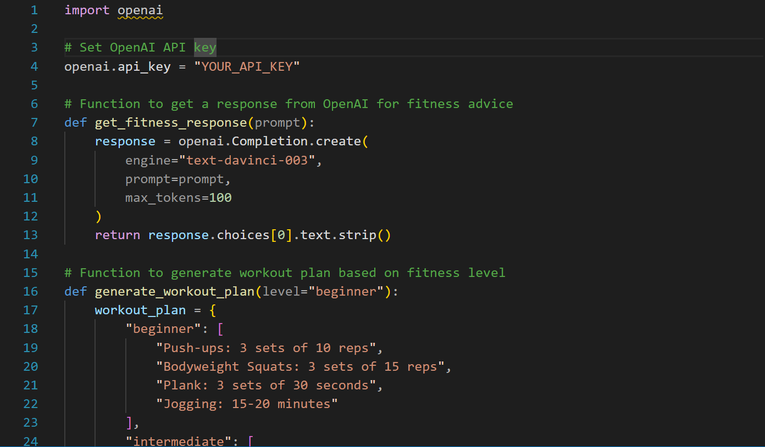

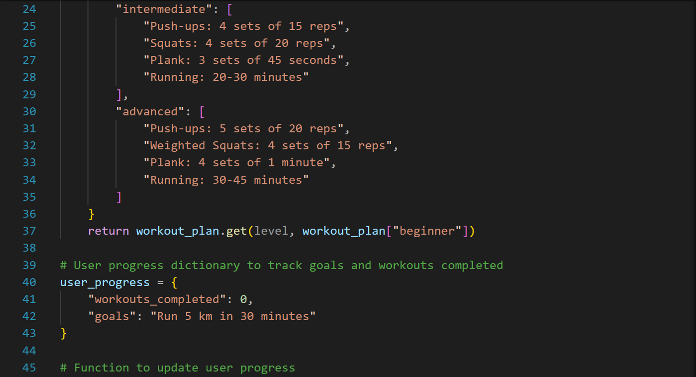

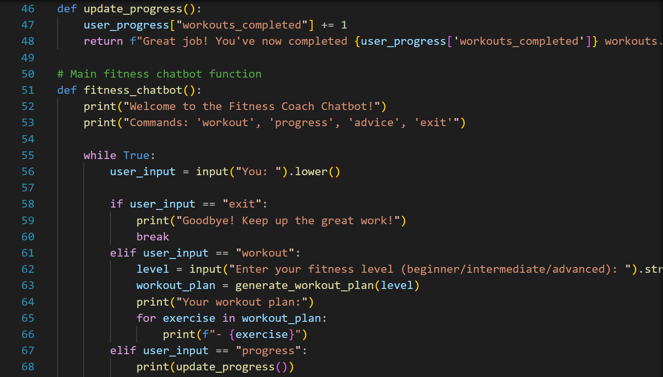

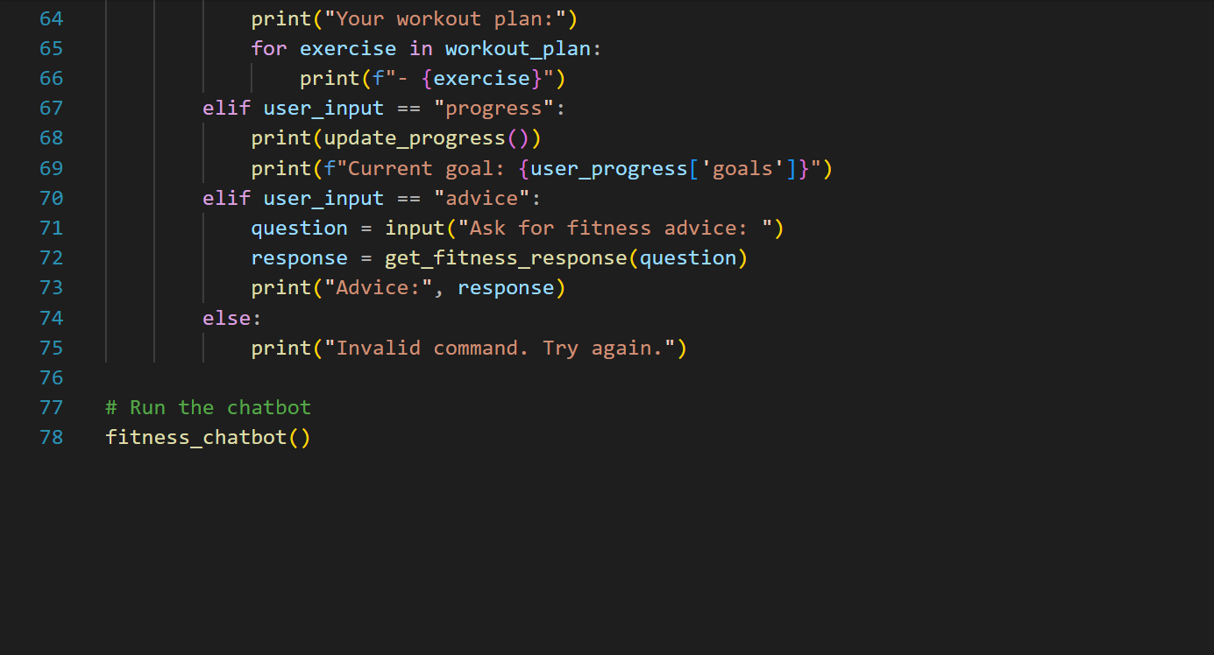

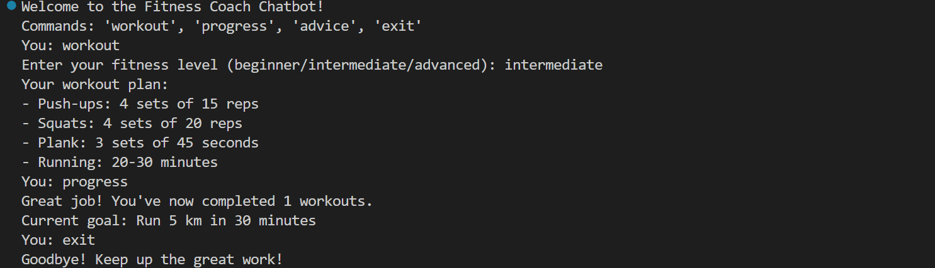

CHAPTER:- Conclusion & Future Scope

Conclusion:

Summarize the project, its successful aspects, and how it addresses the need for a virtual fitness assistant.

Highlight the chatbot’s impact on users, such as providing personalized guidance, motivation, and educational fitness support.

Future Scope:

Suggest future improvements, such as:

Enhanced AI Algorithms: Implement more advanced AI algorithms for improved personalization.

Wearable Integration: Integration with fitness devices to automatically log user activities.

Expanded Functionalities: Add mental wellness support, diet tracking, or more workout plans.

Multilingual Support: Develop language support for a wider user base.

Advanced Analytics: Enable users to receive insights and trends based on their long-term fitness data.

